

MSc in Computing (Information Systems Processes)

**The Role of Artificial Intelligence in Enhancing Product Quality and Efficiency in Industry 4.0**

Student Name Abdul Wahab

Student id: 20104763

Supervisor: Dr. Sinead O'Neill

22nd February, 2024

**Table of Content**

Chapter 1 Introduction: 4

Define Manufacturing Companies. 4

Different Sectors of Manufacturing Companies 5

The role of Efficiency in Manufacturing Companies 6

Role of Quality in Manufacturing Companies 7

Evolution of Industry 7

Evolution of Quality 9

Impact of Industry 4.0 to the world 11

Role of AI in Manufacturing 13

Statement of Problem: 14

1.4 Research Objectives 14

1.5 Research Questions 15

1.6 Research Goals: 15

Chapter 3: Working Hypothesis 15

Chapter 4: Research Methods 15

References 17

**Table of Figures**

Figure 1(Engineering Product Design, 2022) 5

Figure 2(Industrialinfo.com, 2023) 7

Figure 3 (Vikas Mudgil, 2018) 9

Figure 4 (ResearchGate, 2022) 12

Figure 5 orangemantra.com,2023 14

# Chapter 1 Introduction:

Today, artificial intelligence (AI) is changing how factories work, making a big difference in manufacturing. This dissertation looks at how AI helps make things better and faster in factories, which is important because factories are always looking to make products better, reduce mistakes, and save money.

The reason we're talking about this now is because of something called Industry 4.0. This is a fancy way of saying that factories are using more computers and technology to become smarter. AI is a big part of this change because it can look at lots of data to help fix machines before they break, make decisions without humans, and keep improving how things are made.

This study will look closely at the ways AI is used in factories to make sure products are good quality and to help the factory run smoothly. We're going to look at real examples, what's happening right now, and what could happen in the future with AI in manufacturing. This is not just about understanding how AI is changing factories today, but also about thinking about what could come next.

We're going to focus on how AI, like learning machines, watching and understanding images, and robots that do tasks on their own, is being used in different kinds of making things. By looking at both stories from real factories and numbers, this study will try to show how AI is helping make better products, cut costs, and bring new ideas to life.

## Define Manufacturing Companies.

Manufacturing companies are like big kitchens that cook up things we use every day, but instead of food, they make stuff! They take raw materials, like metal, wood, or fabric, and use machines, tools, and sometimes even robots to turn them into finished products.

Think of toys, clothes, cars, furniture, even the phone you're using – all these things were made by a manufacturing company. These companies are important because they create jobs, keep the economy going, and give us the things we need and want. (Anna De Carolis et al., 2017)

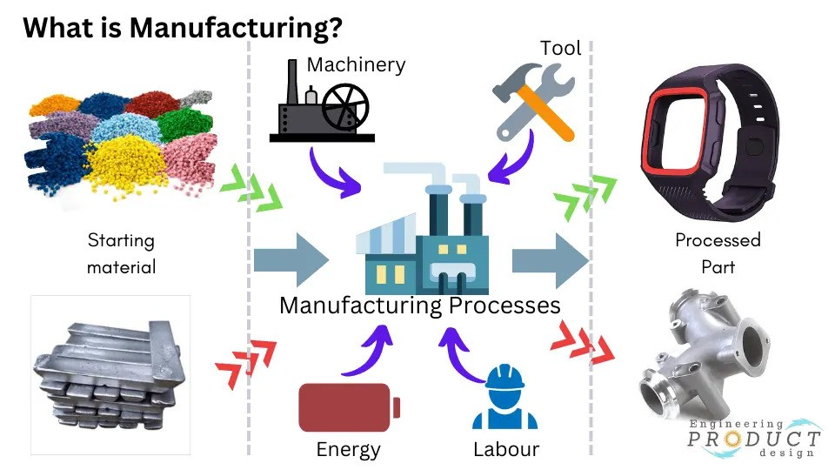

Figure (Engineering Product Design, 2022)

## Different Sectors of Manufacturing Companies

Manufacturing companies can be categorized based on what they produce and how they produce it. Here's a simple breakdown of different types of manufacturing companies:

1. **Consumer Goods Manufacturing**:

These companies make products that are directly sold to consumers. Examples include clothing, electronics, and food products. They focus on products people use in their daily lives.

1. **Industrial Goods Manufacturing**:

These companies produce goods used by other businesses to make products or provide services. Examples include machinery, tools, and equipment. The products they make are usually not directly seen by consumers but are essential for making consumer goods or for services like construction and manufacturing.

1. **Automotive Manufacturing**:

Companies in this category specialize in producing vehicles and vehicle parts. This includes everything from cars and trucks to components like engines and transmissions. They might produce vehicles for consumers or specialized vehicles for industries like construction and transportation.

1. **Chemicals Manufacturing**:

These companies produce chemical products used in a wide range of industries. This can include everything from basic chemicals for industrial use to pharmaceuticals and cleaning products. The products might be used in manufacturing processes, healthcare, or everyday household items.

1. **Electronics Manufacturing**:

This type of company focuses on creating electronic devices and components. This includes consumer electronics like smartphones and televisions, as well as components like semiconductors and circuit boards used in various industries. (Egeraat and Breathnach, 2018)

1. **Food and Beverage Manufacturing**:

These companies process raw food materials into consumable food and drink products. This can range from fresh, packaged foods to frozen products and beverages. They focus on products for both individual consumers and businesses like restaurants and grocery stores.

1. **Aerospace and Defense Manufacturing**:

Companies in this category produce aircraft, spacecraft, military vehicles, and related components. This includes commercial airplanes, drones, and equipment for national defense. They often work closely with governments and regulatory bodies due to the high level of technicality and security involved.

1. **Textile Manufacturing**:

These companies are involved in making fabrics and textiles from natural and synthetic materials. This can include everything from clothing and upholstery to industrial textiles used in medical applications and automotive interiors. (Egeraat and Breathnach, 2018)

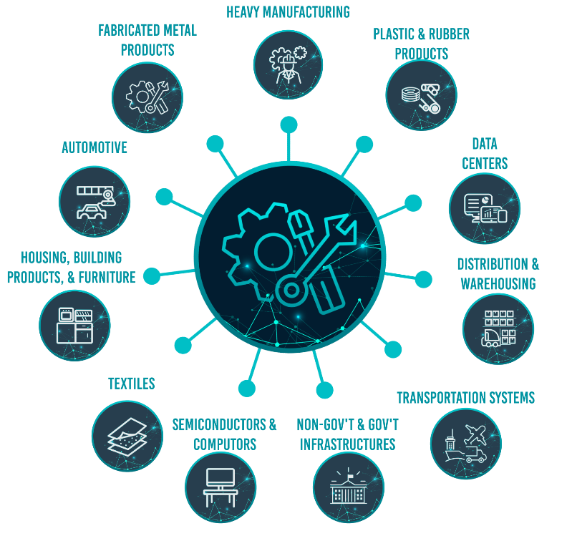

Figure (Industrialinfo.com, 2023)

## The role of Efficiency in Manufacturing Companies

Efficiency in manufacturing companies is like making sure a machine runs smoothly without wasting time, energy, or materials. It's about doing things in the best possible way to make more products, save money, and reduce waste. Here's how efficiency plays a vital role in manufacturing companies, explained simply:

1. **Saves Money**:

When a company is efficient, it uses less materials, energy, and time to make its products. This means it spends less money to produce each item, which can lead to lower prices or higher profits.

1. **Increases Production**:

Efficiency helps companies make more products in less time. If a factory can make 100 items in an hour instead of 50 because it's more efficient, it can meet customer demand better and possibly sell more.

1. **Improves Quality**:

Efficient manufacturing often means paying closer attention to how products are made, which can lead to fewer mistakes and better quality items. High-quality products make customers happy and can lead to more sales.

1. **Reduces Waste**:

Efficiency is also about not wasting materials. This is good for the environment because it means less trash and pollution. It also saves money on materials and can make the company look good to customers who care about the planet.

1. **Stays Competitive**:

In the business world, companies are always trying to be better than their competitors. Being more efficient can help a company offer better prices, better products, or quicker delivery times than others, making it more attractive to customers.

1. **Adapts to Changes**:

Efficient companies are often better at dealing with changes, like new technologies or sudden increases in demand. They can quickly adjust their processes to take advantage of new opportunities or solve problems. (Waltersmann et al., 2021)

In simple terms, efficiency is like making sure every piece of a puzzle fits perfectly, so the whole picture looks good, doesn't waste any space, and can be completed faster. For manufacturing companies, being efficient means they can do their job better, cheaper, and faster, which is good for everyone involved.

## Role of Quality in Manufacturing Companies

Quality in manufacturing is like making sure every piece of a puzzle fits perfectly and the picture looks just right. It's all about making products that meet high standards, work well, and make customers happy. Here's why quality is super important

Top of Form

## Evolution of Industry

1. **Industry 1.0 (Late 18th to Early 19th Century)**:

This is where it all started. Before this time, people made things by hand, which was slow and hard. Then came the steam engine, and it changed everything. Factories began to pop up, using steam power to run machines. This made it possible to produce goods much faster than before. It was the beginning of the industrial revolution, focusing on textiles, iron, and coal.

1. **Industry 2.0 (Late 19th to Early 20th Century)**:

Now we had electricity, which was a game-changer. It led to the assembly line, where products move from worker to worker, and each one does a specific task. This method, famously used by Henry Ford for making cars, made manufacturing much faster and cheaper. It was the era of mass production, with big leaps in steel making, railroads, and telegraph communication.

1. **Industry 3.0 (Late 20th Century)**:

Enter computers and robots. This phase brought automation to factories, where machines began to do the work that people used to do. It made production even faster and more efficient. Computers started to control manufacturing processes, and robots began to assemble products. This era saw the rise of electronics, telecommunications, and the early stages of the internet.

1. **Industry 4.0 (21st Century)**:

Now we're in the age of smart technology. This current phase is all about connecting machines, data, and systems together over the internet. It's called the Internet of Things (IoT). Factories are becoming smarter, using data analytics, artificial intelligence (AI), and more advanced robots. This means they can adjust what they're doing in real-time to improve quality, efficiency, and customization. It's about making manufacturing more flexible and able to meet the specific needs of customers. (Elnaz Asadollahi-Yazdi et al., 2020)

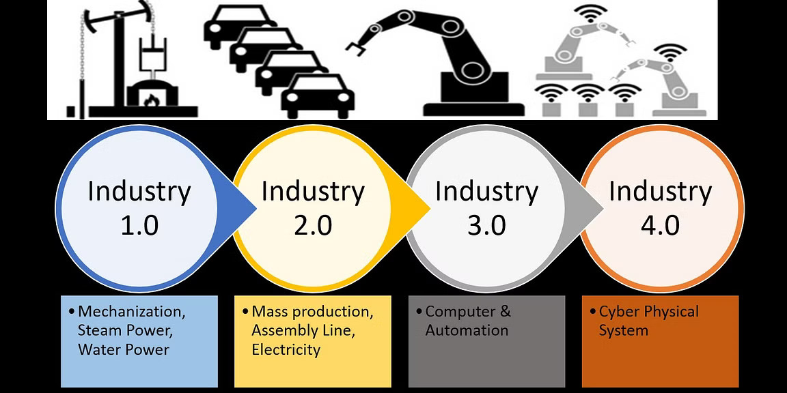

Figure (Vikas Mudgil, 2018)

Industry 4.0 represents the fourth industrial revolution, focusing on the integration of digital technologies into manufacturing. This transformation involves the use of smart technologies and systems to make factories more efficient, flexible, and intelligent. Here's a breakdown of the role of Industry 4.0 in manufacturing companies:

1. **Smart Automation**:

Industry 4.0 introduces advanced robotics and automated systems that can learn and adapt to different tasks without human intervention. This means factories can run more efficiently, with machines handling repetitive or dangerous tasks, freeing up humans for more complex work.

1. **Data and Analytics**:

With Industry 4.0, manufacturing companies can collect and analyze vast amounts of data in real-time. This data helps in making informed decisions, predicting maintenance needs, and optimizing production processes, leading to higher quality products and reduced waste.

1. **Interconnectivity**:

Devices, machines, and systems are connected to communicate with each other and with humans. This Internet of Things (IoT) connectivity ensures a seamless flow of information, enabling the automation of entire production processes and supply chains for better coordination and efficiency.

1. **Customization and Flexibility**:

Industry 4.0 technologies allow manufacturers to offer personalized products as easily as mass-produced ones. Digital manufacturing technologies like 3D printing enable the production of customized products without significant additional cost or time.

1. **Digital Twins**:

A digital twin is a virtual model of a product, process, or system. This technology allows companies to simulate and test scenarios in a virtual environment before applying them in the real world, reducing risks and enabling innovation.

1. **Cybersecurity**:

As manufacturing becomes more connected, the importance of cybersecurity grows. Industry 4.0 includes advanced cybersecurity technologies to protect sensitive data and ensure the safe operation of connected systems.

1. **Sustainability**:

By optimizing production processes and reducing waste, Industry 4.0 contributes to more sustainable manufacturing practices. Smart systems can manage resources more efficiently, decreasing energy consumption and minimizing environmental impact.

1. **Workforce Transformation**:

Industry 4.0 changes the nature of work in manufacturing. It creates demand for new skills, such as digital literacy and the ability to work alongside advanced technologies. This shift requires significant investment in training and education. (Elnaz Asadollahi-Yazdi et al., 2020)

## Evolution of Quality

The way we think about making things well, or "quality," in industries has changed a lot over time. Here's a simple look at how ideas about quality have evolved:

1. **Old Times (Craftsmanship)**:

Long ago, before big factories, skilled workers called craftsmen made things by hand. Because they made each item from start to finish, they made sure everything was done really well. The quality was high because each craftsman took pride in their work.

1. **Industrial Revolution (1800s)**:

When machines and factories started to pop up, making lots of things quickly became more important than making sure each thing was perfect. Factories focused on making as many products as possible, and sometimes quality wasn't so great because it was hard to keep an eye on everything.

1. **Early 1900s (Quality Checks)**:

People started to realize that not making things well could waste time and money. So, they began checking products at the end of the production line to find and remove the bad ones. This was like the first step toward really thinking about quality in factories.

1. **Mid 1900s (Quality Control)**:

Some smart folks, like Deming and Juran, taught companies that they should not just find the bad products at the end; they should make sure things are done right from the start. This idea helped factories make better stuff and not just throw away the bad ones.

1. **Late 1900s (Total Quality Management)**:

Then came a big idea called Total Quality Management (TQM). This meant that everyone in a company, from the boss to the workers, should care about making things well. It was all about teamwork, constantly getting better, and making sure customers are happy. (The evolution of quality: from inspection to quality 4.0 | Emerald Insight, 2021)

1. **Now (Quality 4.0)**:

Today, we're using cool tech like the Internet, computers that can learn (artificial intelligence), and gadgets that talk to each other (Internet of Things) to keep making quality even better. This means we can watch how things are made all the time and fix problems super fast, sometimes even before they happen!

So, over time, the idea of quality has grown from just checking things at the end to making sure everything is done right from the beginning, and now to using technology to help keep everything running smoothly and making customers happy.

Quality 4.0 in manufacturing companies signifies the integration of advanced digital technologies into traditional quality management systems to enhance the efficiency, accuracy, and agility of quality assurance processes. It is a key component of the broader Industry 4.0 movement, which aims to transform manufacturing through digitization and automation. Here are the critical roles and benefits of Quality 4.0 in manufacturing: (The evolution of quality: from inspection to quality 4.0 | Emerald Insight, 2021)

1. **Real-time Quality Monitoring**:

Quality 4.0 enables continuous, real-time monitoring of production processes through sensors and IoT (Internet of Things) devices. This allows for immediate detection and correction of quality issues, minimizing defects and ensuring that products meet the required standards.

1. **Predictive Analytics**:

By leveraging big data and predictive analytics, manufacturers can anticipate and prevent potential quality issues before they occur. This predictive approach to quality management helps reduce downtime, waste, and costly recalls, while also extending the lifespan of manufacturing equipment.

1. **Increased Process Efficiency**:

Automation and advanced analytics optimize production processes, making them more efficient and reducing variability. This leads to consistent product quality and higher customer satisfaction.\

1. **Enhanced Decision-making**:

Quality 4.0 provides decision-makers with comprehensive insights into the manufacturing process, based on data collected from across the production lifecycle. This information supports more informed and timely decisions, improving overall operational efficiency.

1. **Supply Chain Transparency**:

With Quality 4.0, companies gain better visibility into their supply chains, allowing for improved quality control from raw materials to finished products. This transparency ensures that all components meet quality standards, contributing to the final product's integrity.

1. **Customization and Flexibility**:

Digital technologies enable manufacturers to more easily customize products to meet specific customer requirements without compromising on quality. This flexibility supports the production of small batches and individualized products as efficiently as mass production.

1. **Employee Empowerment**:

Quality 4.0 tools provide employees with access to information and analytics, empowering them to take proactive steps in quality management. This empowerment can lead to a more engaged workforce and a culture of continuous improvement.

1. **Regulatory Compliance**:

Automated systems and digital documentation simplify compliance with regulatory standards and quality certifications. Companies can more easily track and demonstrate their adherence to industry regulations, reducing the risk of non-compliance penalties.

1. **Sustainability**:

By optimizing resource use and reducing waste, Quality 4.0 contributes to more sustainable manufacturing practices. This not only helps companies meet environmental regulations but also appeals to increasingly eco-conscious consumers. (The evolution of quality: from inspection to quality 4.0 | Emerald Insight, 2021)

## Impact of Industry 4.0 to the world

Industry 4.0, or the Fourth Industrial Revolution, is changing the world in many significant ways. This revolution is all about making everything smarter—factories, machines, and even products—by using technology like the Internet of Things (IoT), artificial intelligence (AI), robotics, and big data. Here's how Industry 4.0 is impacting the world:

1. **Work and Jobs**:

Industry 4.0 is creating new types of jobs, especially for people who are good at working with technology. But, it's also making some traditional jobs less necessary because machines and software can do them. This means that people need to learn new skills to work with the new technology.

1. **Manufacturing**:

Factories are becoming smarter and more efficient. Machines can talk to each other and to the people working with them, making it easier to make things quickly and with fewer mistakes. This means products can be customized for each person without making them too expensive.

1. **Economy**:

Industry 4.0 can make businesses more profitable by helping them save money on labor and materials and get their products to market faster. This can lead to lower prices for consumers and higher profits for companies. It also makes the global economy more competitive as companies all over the world adopt these technologies.

1. **Society**:

As products become smarter (like cars that can drive themselves), our daily lives could become safer and more convenient. However, there are also challenges, like privacy concerns and the risk of relying too much on technology.

1. **Environment**:

Industry 4.0 has the potential to make manufacturing and other industries less harmful to the environment. Smart factories can use energy and materials more efficiently, reducing waste and pollution. Plus, better data and tracking can help companies understand and lessen their environmental impact.

1. **Education and Training**:

The demand for new skills means that education and training systems need to change. Schools and training programs are starting to focus more on STEM (science, technology, engineering, and mathematics), critical thinking, and problem-solving to prepare people for the jobs of the future.

1. **Healthcare**:

Industry 4.0 technologies are also impacting healthcare by improving how we diagnose and treat illnesses. For example, AI can help read medical images more accurately, and wearable devices can monitor patients' health in real-time.

1. **Global Supply Chains**:

Technology makes it easier for companies to manage their supply chains, even when parts of those chains are spread out all over the world. This can make products cheaper and more available but also makes the global economy more interconnected and complex. (Szozda, 2017)

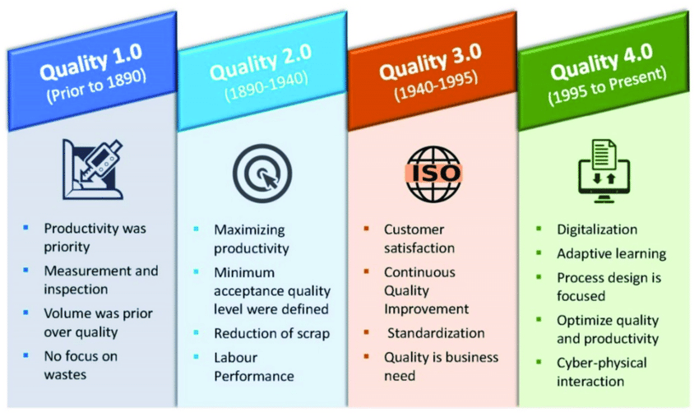

Figure (ResearchGate, 2022)

## Role of AI in Manufacturing

Artificial Intelligence (AI) is playing an increasingly crucial role in transforming manufacturing companies, driving efficiency, innovation, and competitiveness. Here's how AI impacts manufacturing:

1. **Predictive Maintenance**:

AI analyzes data from machinery to predict when equipment might fail or require maintenance. This proactive approach prevents unexpected downtime, extends the life of equipment, and saves costs related to emergency repairs and lost production time.

1. **Quality Control**:

AI systems can inspect and analyze products at a speed and accuracy level far beyond human capabilities. By identifying defects or deviations from the desired quality in real-time, manufacturers can ensure higher quality standards and reduce waste.

1. **Supply Chain Optimization**:

AI algorithms can predict supply and demand trends, optimize inventory levels, and identify the most efficient routes and methods for logistics. This helps in reducing lead times, lowering costs, and improving customer satisfaction.

1. **Smart Manufacturing**:

Through the integration of IoT (Internet of Things) and AI, factories become smarter. AI can control and optimize production processes in real-time, adjusting conditions as needed to maximize efficiency and minimize waste.

1. **Customization and Personalization**:

AI enables manufacturers to offer personalized products by quickly adapting production lines to customer specifications. This flexibility allows for the efficient production of customized products without significantly increasing costs.

1. **Robotics and Automation**:

AI-driven robots can perform complex tasks with precision and flexibility. They can work alongside humans, taking on repetitive, physically demanding, or dangerous tasks, thereby improving safety and freeing up human workers for more skilled roles.

1. **Energy Efficiency**:

AI can monitor and manage energy use throughout manufacturing facilities, identifying patterns and suggesting adjustments to save energy. This not only reduces costs but also contributes to sustainability efforts.

1. **Human-Machine Interaction**:

Advanced AI makes it easier for humans to interact with machines, using natural language processing (NLP) and virtual assistants. This enhances the usability of complex machinery and systems, making it easier for workers to operate and troubleshoot them.

1. **Data-Driven Decision Making**:

AI's ability to process and analyze vast amounts of data enables better-informed decision-making. Manufacturers can use insights gained from AI to optimize their operations, develop new products, and enter new markets.

**Worker Safety and Ergonomics**: AI-powered systems can monitor the work environment to ensure safety protocols are followed and can identify potential hazards. This improves the overall safety and well-being of the workforce. (Ramirez-Asis et al., 2022)

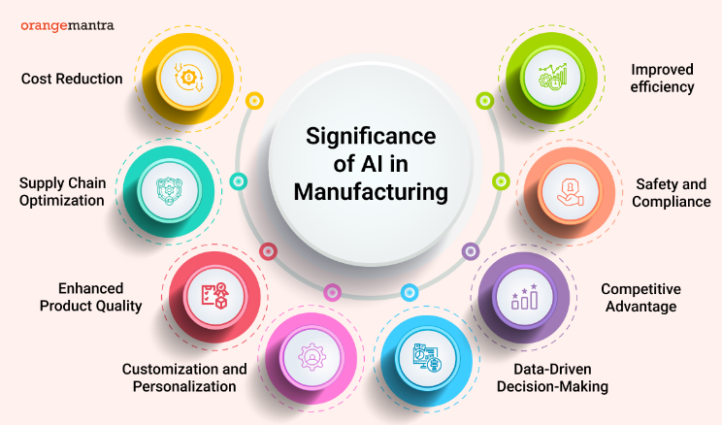

Figure orangemantra.com,2023

## ****Statement of Problem:****

While the manufacturing industry faces increasing pressure to improve quality, efficiency, and competitiveness, traditional methods are often reaching their limits. The rise of Artificial Intelligence (AI) presents a transformative opportunity, but many manufacturers struggle to understand and implement its potential effectively. Despite the recognized potential of Industry 4.0 to revolutionize manufacturing by integrating digital technologies such as the Internet of Things (IoT), artificial intelligence (AI), and big data analytics, its global adoption across industries remains uneven and slow. This reluctance or delay poses significant questions about the underlying challenges and barriers to adoption. High initial costs, a skills gap, cybersecurity concerns, cultural and organizational resistance, unclear ROI, integration challenges with existing systems, regulatory and compliance issues, and varying access to necessary technology and infrastructure are all cited as potential obstacles. Understanding why these barriers exist and how they can be overcome is critical for industries aiming to remain competitive in a rapidly evolving digital landscape.

## 1.4 Research Objectives

The main goal of this study is to look closely at how Artificial Intelligence (AI) can really change the game when it comes to making things better and more efficiently in different kinds of factories, all under the big umbrella of Industry 4.0. We want to figure out what's getting in the way—be it tech problems, company issues, or money matters—of using AI more widely. At the same time, we're going to spot which AI tools (like learning from data, helping computers "see," or predicting what's going to happen next) work best for making sure things are made well and run smoothly, no matter if we're talking about making cars, planes, medicines, or anything else.

## 1.5 Research Questions

This dissertation will explore the following research questions:

* What are the principal technical, organizational, and financial barriers to adopting AI in manufacturing, and how do they differ across industry segments and company sizes?

Which specific AI applications (e.g., machine learning, computer vision, and predictive analytics) are most effective in enhancing quality control and efficiency across different manufacturing sectors (e.g., automotive, aerospace, pharmaceuticals)?

## 1.6 Research Goals:

The goals of this dissertation are to

* Figure out what's stopping companies from using AI more. This includes looking at problems with technology, how companies are organized, and how much it costs to start using AI.
* Find out how AI can make making things (like cars, planes, and medicines) better and faster across different types of factories.

# Chapter 3: Working Hypothesis

Hypothesis 1: SME manufacturers in Ireland that actively use social media analytics are more likely to experience growth in their business than those that do not.

Hypothesis 2: The primary reason why SME manufacturers in Ireland are hesitant to use online advertising is because they believe it is too expensive or ineffective.

# Chapter 4: Research Methods

As there is a rapid rise in Social media analytics researches, there are various diverse methodologies and approaches which provides us with a better understanding of how the to engage more customers using SM Marketing.

Research Question 1:

What are the most effective ways to use social media analytics to drive small manufacturing business growth in Ireland?

Research Method

Case Studies: Conduct case studies of SME manufacturers in Ireland that have successfully used social media analytics to drive growth. This will provide real-world examples of how these strategies have been implemented and their impact on business performance.

Research Question 2:

Why don't many small to medium-sized (SME) manufacturers in Ireland advertise their products and services online?

Research Method

Survey: Conduct a survey of SME manufacturers in Ireland to gather their insights on online advertising. This will provide data on their current practices, perceptions, and barriers to adoption.

The evolution of quality: from inspection to quality 4.0 | Emerald Insight. (2021). *International Journal of Quality and Service Sciences*, [online] 14(3), pp.368–382. doi:https://doi.org/10.1108//IJQSS.

‌ Szozda, N. (2017). *LogForum*, [online] 13(4). doi:https://doi.org/10.17270/j.log.2017.4.2.

‌

# References

Anna De Carolis, Macchi, M., Negri, E. and Terzi, S. (2017). Guiding manufacturing companies towards digitalization a methodology for supporting manufacturing companies in defining their digitalization roadmap. *2017 International Conference on Engineering, Technology and Innovation (ICE/ITMC)*. [online] doi:https://doi.org/10.1109/ice.2017.8279925.

‌

Egeraat, V. and Breathnach, P. (2018). The Manufacturing Sector - MURAL - Maynooth University Research Archive Library. *Maynoothuniversity.ie*. [online] doi:https://mural.maynoothuniversity.ie/9489/1/PB_manufacturing%202007.pdf.

Waltersmann, L., Steffen Kiemel, Stuhlsatz, J., Sauer, A. and Miehe, R. (2021). Artificial Intelligence Applications for Increasing Resource Efficiency in Manufacturing Companies—A Comprehensive Review. *Sustainability*, [online] 13(12), pp.6689–6689. doi:https://doi.org/10.3390/su13126689.

Elnaz Asadollahi-Yazdi, Paulin Couzon, Nhan Quy Nguyen, Yassine Ouazene and Farouk Yalaoui (2020). Industry 4.0: Revolution or Evolution? *American Journal of Operations Research*, [online] 10(06), pp.241–268. doi:https://doi.org/10.4236/ajor.2020.106014.

‌ Ramirez-Asis, E., Vilchez-Carcamo, J., Thakar, C.M., Khongdet Phasinam, Thanwamas Kassanuk and Mohd Naved (2022). A review on role of artificial intelligence in food processing and manufacturing industry. *Materials Today: Proceedings*, [online] 51, pp.2462–2465. doi:https://doi.org/10.1016/j.matpr.2021.11.616.

‌

‌

‌

‌

‌

‌

‌

‌

‌

‌

‌

‌

‌